

**Christ University, Faculty of Engineering.**

**Department of Computer Science and Engineering.**

**Internet of Things for Smart Rooms and Buildings**

*By*

M Shankar Ganapathy

1660478

IV Semester, 2018

Performed at

### **Centre for Development of Advanced Computing**

### No 1, Old Madras Road, adjacent to Baiyappanahalli metro station, Bengaluru, Karnataka 560038, India.

**Internship Period: 1/04/18 – 31/05/18**

**CONTENTS**

|  |  |  |  |
| --- | --- | --- | --- |
| **Abstract** | | | **i** |
| **Preface** | | | **ii** |
| **Table of Contents** | | | **iii** |
| **List of Symbols and Abbreviations** | | | **v** |
|  | | |  |
| **Chapter 1.** | | **Introduction** |  |
| **1.1.** | **Background & Objectives** | | **6** |
| **1.2.** | **Main Contribution** | | **7** |
|  | | | |
| **Chapter 2.** | |  |  |
| **2.1.** | **Project Specifications** | |  |
|  | **2.1.1.** | **Prerequisites** | **8** |
|  | **2.1.2.** | **Responsibilities** | **8** |
|  | | | |
| **2.2.** | **Learning outcomes** | |  |
|  | **2.2.1.** | **Working of a client-Server Model** | **9** |
|  | **2.2.2.** | **Implementation of TCP protocols to accept data** | **10** |
|  | **2.2.3** | **Database and Mail connectivity and Application** | **10-11** |
|  | | | |
| **Chapter 3.** | | **Code** |  |
| **3.1.** | **Config.java** | | **12** |
| **3.2.** | **TCPSERVER.java** | | **13-14** |
| **3.3.** | **SqlSaveData.java** | | **15-16** |
| **3.4** | **ErrorEmailReply.java & GenEmailReply.java** | | **16-17** |

|  |  |  |  |
| --- | --- | --- | --- |
| **Chapter 3.** | | **Conclusions** |  |
| **3.1.** | **Conclusion** | | **18** |

**Acknowledgement:**

I would like to express my heartfelt gratitude to Mr Hari Babu P, Principal Technical Officer (UCHR), CDAC Bengaluru for giving me a chance to explore and dive into this booming field in Technology used in abundance even in the years to come.

I would also like to express my gratitude towards my teacher Professor Balamurugan from Christ University for their kind cooperation and encouragement in taking new challenges in this upcoming field of Information Technology.

I would also like to mention the extra effort that Mr Aman Kale, PE, RTS &IoT Group put in, in helping me understand this new field and debug some of the unique errors that I faced in my code.

I extend my gratitude to my fellow trainees for helping me in not only getting used to the environment but also for sharing their knowledge and helping me out whenever possible.

**Abstract:**

The explosively growing demand of Internet of Things (IoT) has rendered broad scale advancements in the fields across sensors, radio access, network, and hardware/software platforms for mass-market applications. In spite of the recent advancements, limited coverage and battery for persistent connections of IoT devices still remain a critical impediment to practical service applications. IoT Devices have a lot of implementations in a smart House/ room depending on their need.

Here my Internship deals with the introduction of IoT Devices to office buildings or closed rooms where one would have to rely on air-conditioning for the necessary ventilation.

**Preface:**

As a part of B.Tech Curriculum, we are needed to carry out projects in various fields pertaining to the subject and I have carried out this project in the field IOT.

The motive behind this project is to gain an insight into this booming field hence develop the necessary knowledge required to work in this field in future.

This project deals with the creation of a client-server model which can handle the data sent from the IoT Device in the form of TCP packets and in-turn give an analysed and presentable view of what that means to the user.

**Chapter 1. Introduction**

**1.1 Background & Objectives**

IOT is an ecosystem of connected physical objects that are accessible through the internet. There is an embedded technology in the objects helps them to interact with internal states or the external environment.

In offices or closed rooms in buildings, there is a need to continuously monitor the temperature, humidity or other factors that may play a role in how well people or employees work efficiently. Here the primary focus is on the occupants of a room, may they be people in homes, shops etc or employees at offices.

The data collected from the IoT Devices that have sensors would help in processing that data to make changes to the situation of that room at that moment.

Now IoT devices have a lot of sensors depending on use and hence generate huge amounts of data, which intern has to be handled by a server capable of storing and working on that data which may be used later.

**1.2 Main Contribution**

This project deals with a combination of hardware and software side. I work on the Software side which deals with the setting up of the server and necessary features required by the client like storing data to database and intimation through mail on stored data. While the Hardware side deals with the actual IoT device which transmits the data collected from sensors in JSON format.

**1.2.1 Workflow of the Project**

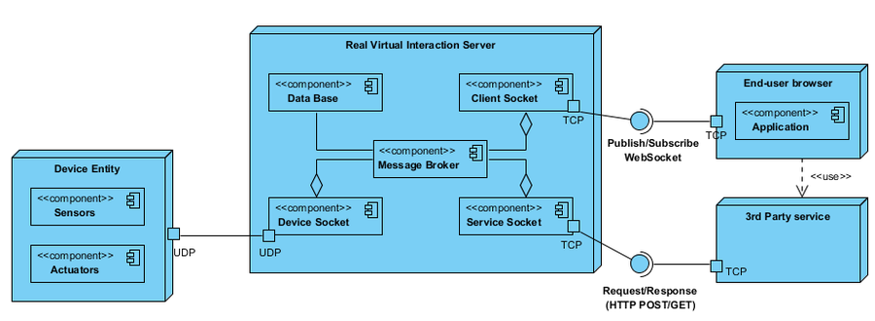

The project follows a similar workflow where data is received from a device entity with the help of its sensors and actuators.

This data is then passed on to the Server where it would be stored in the database with the help of sockets.

Data is sent to and fro from the client to the server and at times to a 3rd party service depending upon need like a service that analyses and predicts some valuable information.

**Chapter 2.**

**2.1 Project Specifications**

The project involved the use of varied languages ranging from Java to JSP to JavaScript and XML in different environments. Below I have mentioned the specification of the project.

**2.1.1 Prerequisites**

This project deals with the integration of many different types of files in an Eclipse IDE.

1. Understanding of Client-Server Model
2. Implementation of TCP & HTTP protocols in java
3. Basic knowledge of MySQL.

**2.1.2 Responsibilities**

My responsibility in this project is to create a server capable of handling multiple requests while it processes and stores the data that it receives from multiple, similar IoT devices.

Once the data received is processed some calculation have to be made on it depending on the device ID and the respective user has to be informed by mail about the recent developments or problems they would face if any.

**2.2. Learning Outcomes**

Client-Server Model

The Client-Server architecture used here is a 3-Tier Client-Server Architecture where the client (through the browser) requests the resources from a server.

There is an intermediate application server which again requests resources from a data server.

The application server is the one that deals with the actual Client using an interface, while the data server is the one that processes and stores the required data in the database for later usage.

The application server is multithreaded to be able to access multiple client-requests and works with the help of servlets because of the usage of the Dynamic web page. There is also an XML file that deals with the mapping of the servlet with their respective HTML and JavaScript.

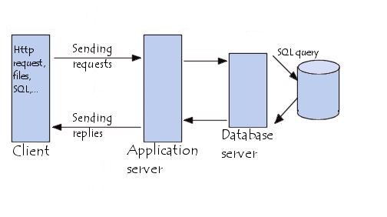

Implementation of TCP/IP Sockets

Most Web applications use sockets to implement network communication protocols to transfer required data to and from the server. TCP is a connection-oriented protocol; on the other hand, a connection must be established before communications between the pair of sockets start. TCP is a reliable protocol it is guaranteed that the packets you send will be received in the order in which they were sent. This can be implemented using the “Socket” class which has parameters IP address and Port number. There should be two sockets to establish a connection a client and server socket along with an input and output stream for the transfer of data to and from the server.

2.2.3. Database and Mail Connectivity

In this project there is a need to save all the data received from the IoT Devices hence I have used MySQL to store this data into five tables

* Data table: This table stores acceptable data values for processing.
* Error table: This table stores the data that cannot be used because of constraint violation.
* FromMail table: to store the username, password, port and host through which the mails would be sent.
* ToMail table: This table stores the recipient’s Name and email address.
* ThreshHoldData table: This table stores the threshold and critical values for the respective IoT devices.

To access these tables from the database I have used

“mysql-connector.jar” corresponding to the JDK I am using.

To send and receive mails we have to import some special classes which are available from “activation.jar” and

“mail.jar “files. Depending on the host i have configured the authentication process to send email to users from one standard email address. Later to send an email I have retrieved the recipient’s information from the database and used it whenever necessary.

To send emails four classes have to be used

* Properties: This deals with the authentication of the sender’s email address with the password.
* Session: This takes care of opening a dialog/session for the email to be sent.
* MimeMessage: which takes care of the To, From, BCC, CC, Subject and Message in the email.
* Transport: This takes care of the sending of an email.

**Chapter 3. Code**

**Config.java**

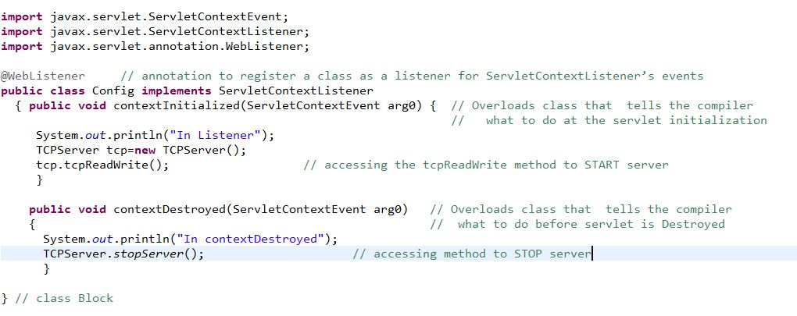

**TCPServer.java**

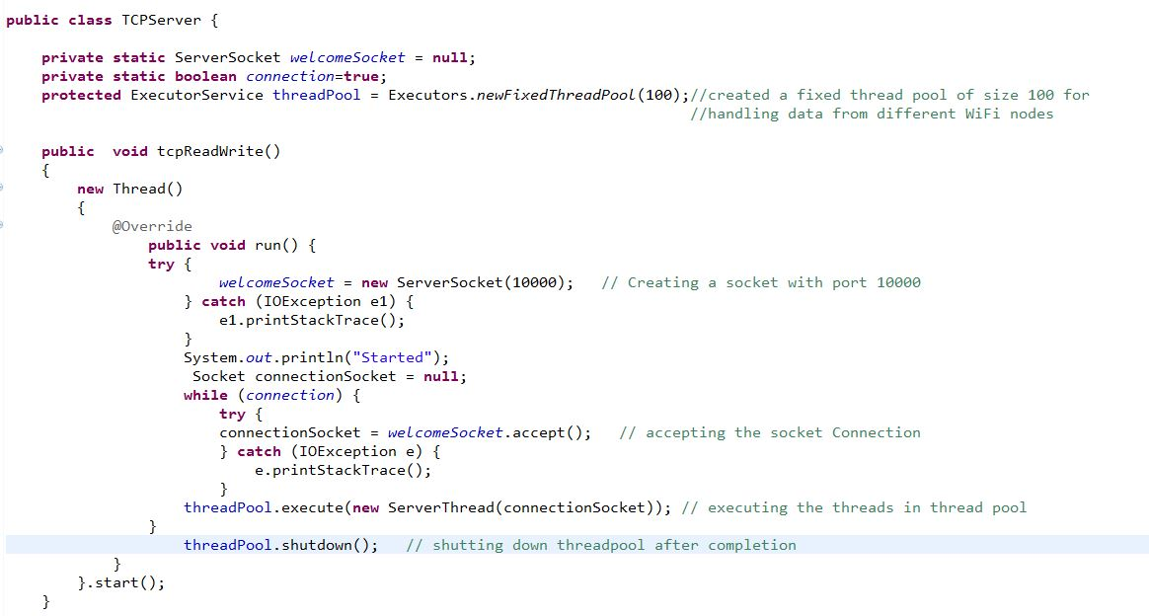

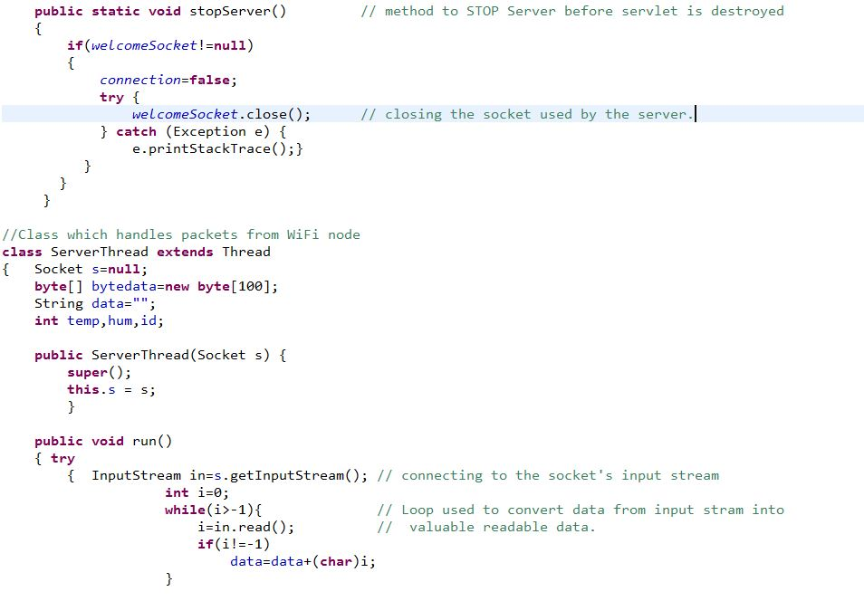

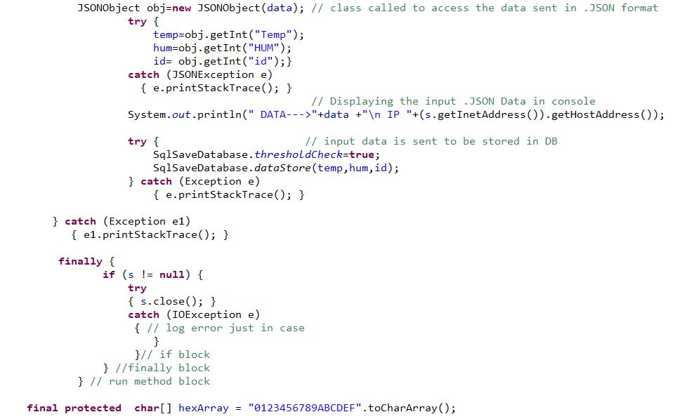



**SqlSaveData.java**

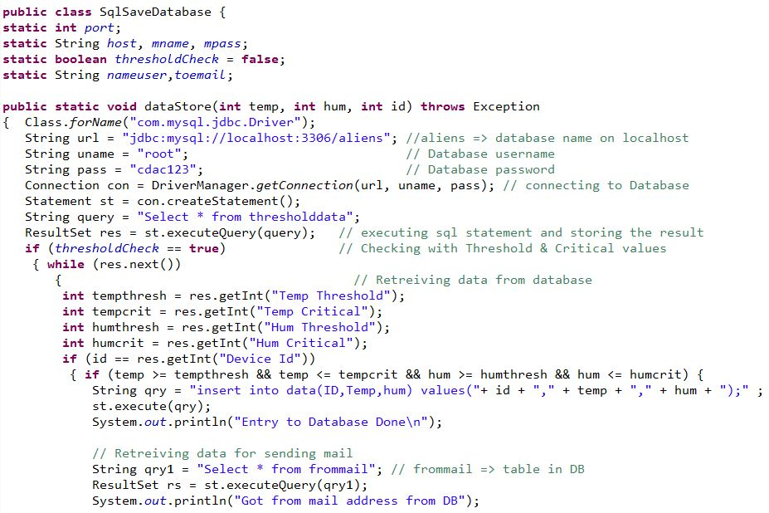

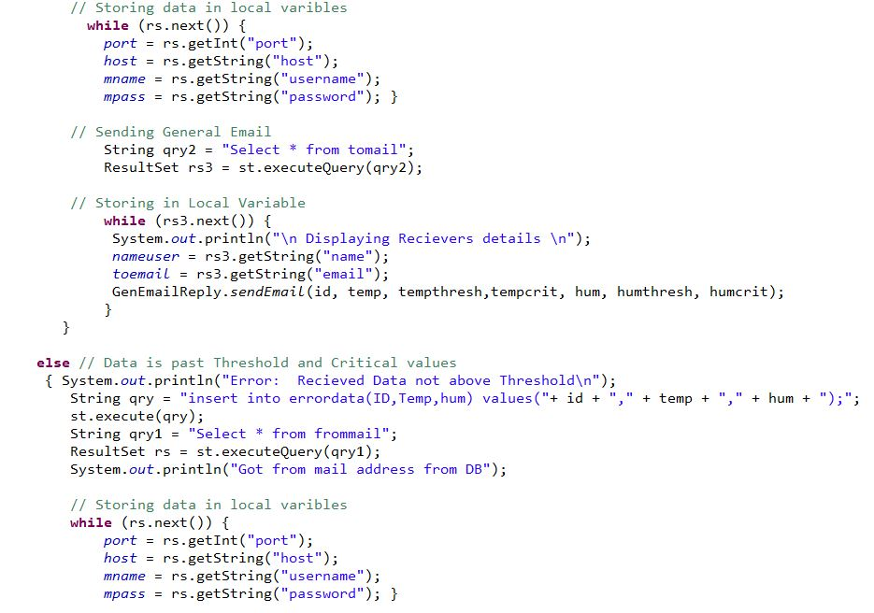

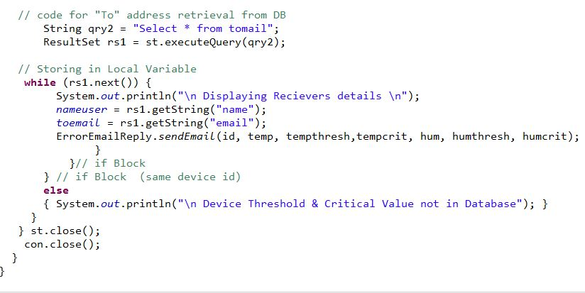

**ErrorEmailReply.java**

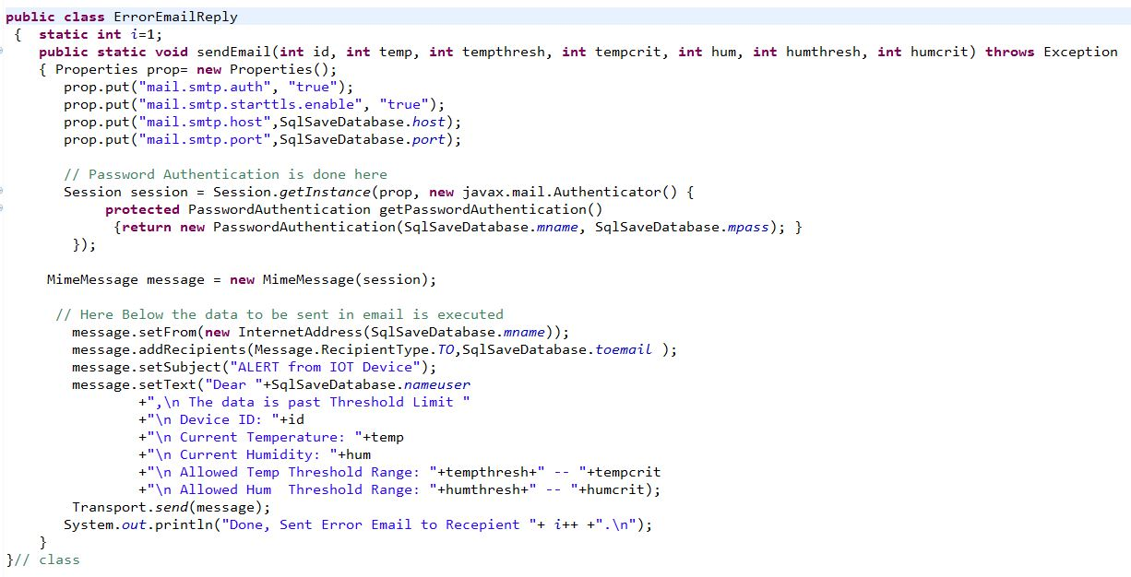

**GenEmailReply.java**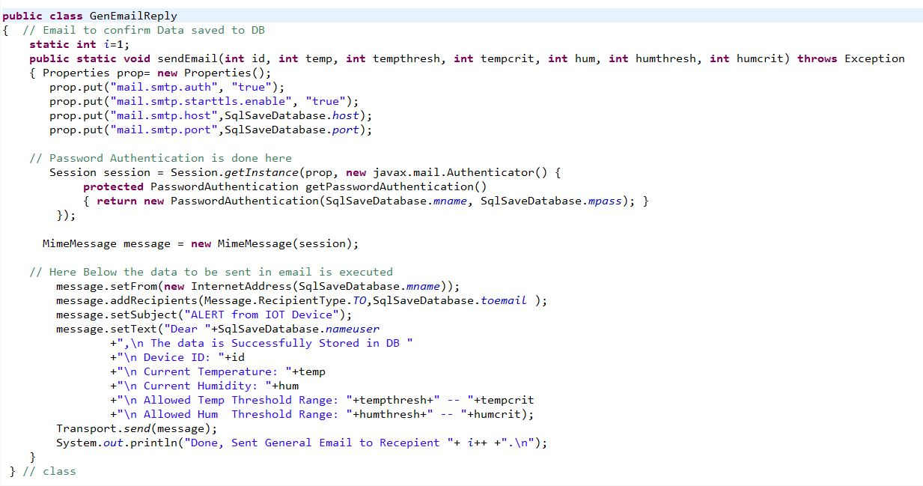

**Chapter 3. Conclusion**

I am glad to have been given a chance to do this project in the field of IoT as it was something that I could not completely understand. Hence this project has given me an understanding of what the world of IoT devices can do to make life easy for everyone. This is the first project where I learnt the meaning of implementing after reading up on the theory of the process, so this has been a great experience and an insight as to what it would mean to work in the field of IoT.